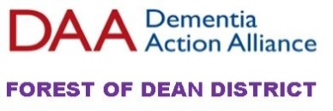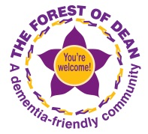

Forest of Dean District Dementia Action Alliance (FODD DAA)
TERMS OF REFERENCE
The overarching aim of the Forest of Dean District Dementia Action Alliance (FODD DAA) is to make sure that everyone in the district living with dementia is understood, respected, supported and enabled to continue to enjoy living their lives in their own community as well as possible for as long as possible.

To support the wider community to understand dementia and inspire and enable people to do things which contribute to a dementia friendly community.

OBJECTIVES
- To increase peoples’ knowledge and understanding of dementia
- To increase the number of community buildings which are dementia friendly
- To establish and maintain effective support through information sharing networks
- To ensure that the voices of people with dementia, their carers and families are heard and guide the work of the FODD DAA
- To seek membership from businesses, organisations, community groups and individuals across the Forest of Dean District

The FODD DAA shall not be used as a platform for self-promotion, political promotion or marketing of a business or service.

Members of the Forest of Dean District Dementia Action Alliance (FODD DAA):
- Agree to take responsibility for and deliver their own actions to help improve lives of people living with dementia, their carers and families
- Attend meetings to discuss and update actions
- Increase public awareness and understanding of dementia through their involvement in the Forest of Dean District DAA
- Network, share information and ideas, and support joint learning amongst members of the Alliance
- Work towards creating Dementia Friendly Communities

MEETINGS
- The Forest of Dean District DAA is an informal partnership; it will hold a networking event each year where it updates members on activities and any funding received during the year
- A Steering Group will meet at least four times a year to review activities and progress actions:
members currently FODDC, 2Rivers Housing, Alzheimer’s Society, Crossroads, Newent Association for the Disabled, Carers Glos, Dr Ansell (2getherTrust), Andrew Morgan-Watts, Denise Major, Andrea Harman, Liz Pearce, care services.

CHAIR - Andrew Morgan-Watts, Dementia Champion.

Treasurer
Crossroads Forest of Dean keep the accounts for the FODDAA and produce statements which are reported at the quarterly steering group meeting.
https://www.crossroadsfd.org.uk/dementia-action-alliance/ - this has recently been set up. Members are asked to go on line and feedback via the contact page.

